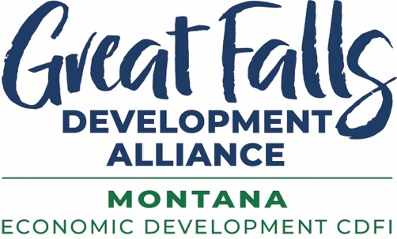

GFDA Quarter Index 2025Q2

Size of site under contract for Project Cardinal hyperscale data center campus: 569 acres
Total building square footage of proposed Project Cardinal campus: 2 million
Estimated capital investment at full buildout: $1-1.5 billion
Projected permanent high wage jobs to be created: 150-200
Projected construction jobs: 1,500-2,000
Total power capacity requested for Project Cardinal: 600 MW
Size of Admiral Beverage/Pepsi Great Falls building under construction in Great Falls AgriTech Park: 100,000 square feet
Number of new affordable senior apartments in Carter Commons development: 24
New apartments and villas to be constructed in Benefis Health System’s Sanavita Estates independent senior living campus: 92
Size of Benefis Health Aging Center under construction: 15,550 square feet
Touro College of Osteopathic Medicine students doing their third-year clinical rotations at Benefis: 48
Single family lots unanimously approved by Great Falls City Commission: 163
Inaugural class of Master of Science graduates at Touro College of Medicine Great Falls: 17
Groundbreakings for indigenous ceremonial centers in Great Falls: 1
Participants in International Economic Development Council’s inaugural Rural Retreat in Great Falls Montana region: 408
Most miles travelled by international participant for Retreat: 4,477
Partners that made Rural Retreat possible: 74
Approximate miles traveled in region during Rural Retreat immersive experiences: 1,600
Housing developer prospect site visits to Great Falls: 3
Proposals submitted to state-generated primary sector leads: 3
Companies met with at SelectUSA Investment Summit 2025: 40+
Impromptu meetings with companies and site selection consultants at SelectUSA: 100+
Transload companies interested in Great Falls at annual Transload Distribution Association North America conference: 3
Great Falls partners that participated in national 2025 Main Street Now conference: 4
GFDA gap and bridge loans closed during quarter: $1,621,600
Additional investment leveraged by these loans: $3,919,082
SSBCI 2.0 loans participated with: $329,600
SBA 504 loans funded: $480,000
Additional investment leveraged by these loans: $720,000
Entrepreneurs and small business (SBDC) clients advised: 216
Rural clients advised: 91
Total client advising hours: 336
Capital secured by small business advising clients: $1,172,357
Entrepreneur and small business trainings: 8
Number of training participants: 75
Business participants graduated from GFDA Winter Entrepreneur Cohort: 8
Government contracting (APEX) clients advised: 111
New government contracting clients advised: 18
Government contracting advising sessions: 146
Active government contracting clients at end of quarter: 274
Government contracts won by clients: $51,446,028
Government contracting trainings: 2
Number of training participants: 35
Free Phase 1 and Phase 2 Brownfield Assessments completed for clients: 3
Page views in first two months of 2025 Livability Great Falls talent attraction magazine: 10.5K
GFDA numbers for FY2025 –
Business Attraction Announcements: $3,956,200,000
Business Expansion Announcements: $1,406,000,000
Business Expansions Completed: $17,400,000
Business Startups helped by GFDA advisors: 22
Capital secured by these startups: $7,700,000
Government contracts won by companies helped by our advisors: $85,000,000
New Apartments constructed and rented: 361
New childcare slots created: 156
Companies that purchased lots in Great Falls AgriTech Park: 4
Acres purchased by companies: 51
Additional acres optioned by companies: 569
Acres GFDA purchased for Park: 36
Additional acres GFDA optioned to expand Park: 42
Gap and bridge loans GFDA made in trade area: $3,348,935
New loan capital GFDA secured: $4,600,000
Entrepreneur Cohort graduates: 18
Female business owners recognized with Fire Within Awards: 53
2025 GFDA Ally Award winners: 21
Best Walleye Fishery in US: Lake Elwell, Montana
US Walleye Tournament record fish caught at Lake Elwell: 143.5 Lbs.

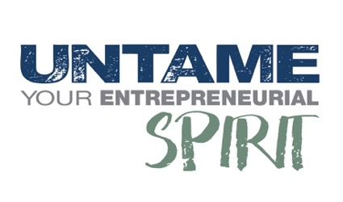
For info contact Jolene Schalper at JSchalper@GrowGreatFalls.org
or 1-406-750-4481

