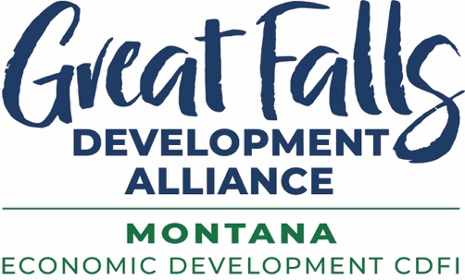

GFDA Quarter Index 2025Q3

Years MAFB USAF Airmen have been on alert 24/7/365 protecting us: 63+
Montana annual property tax estimate on phase 1 of a hyperscale data center: $2.25 million
Average property tax paid annual on a Great Falls home: $2,436
Number of Great Falls homes property tax to equal phase 1 of hyperscale data center: 924
Touro University new medical and graduate student class: 165
Touro COM Great Falls affiliated rotation sites so far: 20
Number of research projects underway at Touro Great Falls: 71
Touro medical student local volunteer hours last year: 5,000+
National and international site selection consultants we hosted at Chicago event: 10
Montana food processing safety videos published by GFDA during quarter: 11
Total views of the safety videos in first few weeks: 533
One-on-one meetings held at APEX Great Falls GovMatch: 655+
Number of units in Bayview multi-family development in Great Falls: 92
In-depth industry market assessments released by GFDA during quarter: 2
Size of largest Pizza Ranch in world opened in Great Falls: 6,000 square feet
National Impact Awards won by GFDA during quarter: 3
Average annual wage increase in Cascade County in four quarters ending 2025Q1: 5.6%
Increase nationwide during same four quarters: 4.2%
Cascade County average annual wage in 2025Q1: $55,479
Increase in total wage earnings in Cascade County in four quarters ending 2025Q1: 5.88%
Total wage earnings increase in Cascade County for those quarters: $120 million
Active housing developments we worked with clients on during quarter: 19
Proposals submitted to state-generated primary sector leads: 3
Companies identified and added to GFDA CRM during quarter: 52
GFDA gap and bridge loans closed during quarter: $712,900
Additional GFDA gap and bridge loans approved during quarter: $1,060,680
Additional private investment to be leveraged by these loans: $2,452,826
New loan capital GFDA secured: $1,264,292
Entrepreneurs and small business (SBDC) clients advised: 189
Rural clients advised: 53
Total client advising hours: 316
Capital secured by small business advising clients: $1,001,792
Entrepreneur and small business trainings: 4
Number of training participants: 37
Indian Equity Fund training participants: 23
Government contracting (APEX) clients advised: 73
New government contracting clients advised: 28
Government contracting advising sessions: 202
Active government contracting clients at end of quarter: 290
Government contracts won by clients: $18,249,388
Government contracting trainings: 2
Number of training participants: 345
New investors joining the GFDA team during quarter: 7
Total number of GFDA Investors at end of quarter: 143
Estimated rooftops in Cascade County that are viable for solar energy: 84%
Projected compound annual growth rate 2025-2030 of global adventure tourism: 16.8%
Percentage of travelers who look for accommodations that offer a variety of experiences throughout their stay: 76%
Population without 90-minute drive of Great Falls: 178,000
Population within a 3-hour drive: 589,000
Population within a 5-hour drive: 1.4 million
Miles of fishable running water in Great Falls region: 3,700
Small businesses already using AI according to US Chamber survey: 58%
Projected 2025 AI infrastructure investments by US large tech firms: $400 billion
Estimate global investment in data centers by end 2028: $3 trillion+
Cybercriminal smartphone attacks worldwide in 2024: 33 million+
Importance of exporting – global buying power outside US: 80%
Expected NFL game wagering by Americans on legal gambling sites this season: $30 billion
Estimated U.S. annual betting through illegal or unregulated operators: $674 billion
Projected highest demand profession in US in next 10 years: Electricians
Annual US demand for new electricians: 81,000
2024 Foreign Direct Investment (FDI) in the US: $5.71 trillion
US consumers who say they increased their protein consumption in 2024: 60%
Increase in US imports of Brazilian beef in first half of 2025: 91%
Lowest year of U.S. beef cattle headcount since data collection started in 1973: 2025
Who produces the best beef in the world: Montana ranchers!
A U.S. comeback story – the city that got hungry enough to change
Amount of debt Detroit had amassed at time of bankruptcy in 2013: $18+ billion
Amount of surplus Detroit had in FY24/25 audit: $60.2 million
Recent commercial developments in downtown Detroit: $6+ billion

For info contact Jolene Schalper at JSchalper@GrowGreatFalls.org
or 1-406-750-4481

