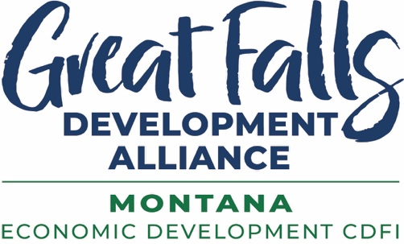

GFDA Quarter Index 2026Q2

Numbers to Celebrate
Janicki Industries capital investment announced for Great Falls campus: $850 million
Square feet of manufacturing space to be built in campus: 1.6 million
Number of aerospace jobs to be created: 2,000+
Electricity controlled 24/7/365 by new BHE Montana Great Falls operations center: 472.5 MW
Capacity of Westinghouse eVinci Microreactor announced for Malmstrom AFB: 5 MW
New homes being built in Meadowview Village development: 163
Units of new housing under construction in Great Falls: 315
Resident capacity of memory loss village development announced by Benefis Health System: 48
Grant won by Great Falls College MSU to expand it’s veterinary tech program: $637,000
New light industrial-zoned sites created in Cascade County: 5 20-acre lots
Revenue increase by a local entrepreneur’s participation in Goldman Sachs small business program: 47%
Out-of-state visitors to Central Montana in 2025: 2.8 million
Estimated local spending by these visitors: $370 million
Dollars spent by visitors to Montana in 2025: $5.6 billion
Construction planned for Malmstrom AFB over next 10 years (on base only): $1.2 billion
Construction planned for Montana Air National Guard over next few years: $300 million
New miles of River’s Edge Trail being constructed by Great Falls Bicycle Club: 2.5
Redevelopment investment to create Sun River Health & Rehab: $6 million
Montana ranking for Most Friendly State: 1st
New business openings and announcements in quarter’s Top 10: 19

GFDA Quarter Numbers
Successful female entrepreneurs recognized with The Fire Within Awards: 52
Community members recognized with GFDA Ally Awards: 19
Out-of-state lead generation trips: 3
Visits to out-of-state primary sector prospect companies: 2
Primary sector prospects who visited Great Falls: 2
Proposals submitted to primary sector Requests for Information (RFIs): 8
National defense related out-of-state trips: 3
Housing developer prospect site visits to region: 8
GFDA gap and bridge loans closed: $1,485,476
Additional private investment leveraged by these loans: $11,764,351
More gap and bridge loans approved: $2,415,000
Additional private investment to be leveraged: $9,233,484
SBA 504 loans approved: $414,000
Additional private investment to be leveraged: $600,000
Entrepreneurs and small business (SBDC) clients advised: 130
Rural clients advised: 54
Total client advising hours: 334
Capital secured by small business advising clients: $1,433,000
Businesses started by advising clients: 3
Businesses purchased by advising clients: 3
Entrepreneur and small business trainings: 10
Number of training participants: 58
Government contracting (APEX) clients advised: 73
New government contracting clients advised: 14
Government contracting advising sessions: 141
Active government contracting clients at end of quarter: 357
Government contracts won by clients: $12,108,834
Government contracting trainings: 2
Number of training participants: 68
Community participants in first River Activation Task Force meeting: 30
Ideas shared by participants: 60+
New loan capital secured by GFDA in FY2026: $3 million
Great Falls AgriTech Park acreage put under sale agreement: 197 acres
Great Falls AgriTech Park acreage put under option agreement: 68 acres
New GFDA Investors in FY2026: 15
GFDA Investors who increased their investment in FY2026: 14
Central Montana Defense Coalition founding investors in FY2026: 23

Recent Economic Data
Average annual wage increase in Cascade County in four quarters ending 2025Q4: 4.7%
Dollar amount of average annual wage increase in Cascade County: $2,552
Cascade County average annual wage in 2025Q4: $57,197
Wage increase nationwide during same four quarters: 3.6%
Total wage earnings increase in Cascade County for those quarters: $81 million

Interesting Factoids
Number of site selection factors ranked by more than three-quarters of
consultants as very important or important in siting decisions: 29
Critical site selection factor ranked top by 100% of consultants: Availability of Skilled Labor
Missing from survey: Availability of Housing & Childcare
Site selection factors ranked critical by 98% of consultants: Site Readiness and Due Diligence Status
Also by 98% of consultants: Electric Power Availability at Scale
By 96% of consultants: Political and Regulatory Stability & Operating Cost Structure
USDA inspected meat processing facilities operating in Montana: 14
Projected annual solar generation growth rate each year from 2026-2030: 27 GW
Projected annual battery storage growth rate each year 2026-2030: 15 GW
Projected annual natural gas generation growth rate each year 2026-2030: 13 GW
Meetings of Montana Governor’s Energy Task Force: 28
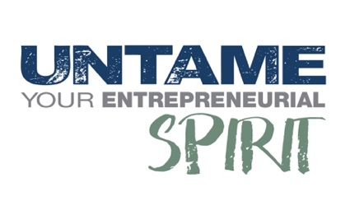
For info contact Jolene Schalper at JSchalper@GrowGreatFalls.org or 1-406-750-4481

